 | Class of ‘Forest Hydrology’ and’ Forest and Hillslope Hydrology’ 2013-14
Written report:
Part 1: Analysis and modelling of the November,1, 2010 flood on the Posina river basin

Part 2: Sensitivity analysis of the Penman-Monteith model for transpiration and for evaporation

Author + enrollment code |  | Date

Document History

Guidelines on report preparation are reported here marked in yellow.
The “Document History” provides a register for the corrections and updating of the document.
Please note that_
- the work for Part 1 is common to all the three groups.
- the work for Part 2 is divided into three groups, which specific Tasks given to each group individually.
Each student will send a copy of the report to the Instructor at least 2 weeks before the oral/registration date.

Date | Revision | Notes
dd/mm/yy | 1_0
 | 1_1
 | 1_2
 | ..

Summary

The Summary provides the context for this work and gives the principal conclusions. It should be up to one page long. The Summary should be written so that results of the work are comprehensible to professionals with a non-technical background (such as policy makers).

Contents

Document History 2
Summary 2
Contents 3
Contents
1. Section 1 4
1.1 Second level title 4
2. Section 2 and onwards 5
2.1 Second level title 5
2.1.1 Third level title 6
2.1.2 Etc. 7
3. References

Part 1: Analysis and modelling of the November,1, 2010 flood on the Posina river basin

  - Introduction

Here you provide a description of the objectives and structure of the work.
The overall objective of the work is to analyse the relationship between rainfall and runoff for a major flood which impacted the Veneto region in the period from 31 October to 2 November 2010. A large, long-lived storm system on the piedmont mountain range system of Veneto (Italy) produced near record flooding in the Posina river basin (116 km²) on November 1, 2010. Areal-averaged storm total accumulations in a 55-hour period between 31 October and November 2 was around 389 mm. The specific objectives of the work are listed as follows:
- Computation of the mean areal hourly precipitation over the Posina river basin by using precipitation data from 7 raingauges;
- Computation of the hourly discharges by using observed stage data at Stancari and rating curve;
- Computation of the base flow;
- Computation of the observed event cumulated rainfall and runoff values;
- Computation of the derived Curve Number value and runoff ratio;
- Development of scenarios with prescribed land use/land cover changes.

In each following section, report a description of the procedure and comment the obtained results.
The computation will be carried out by using Excel files.

  - Presentation of the study basin and of available data

Here you describe the basin and the available data:
- Precipitation data at various stations (report positions of the stations)
- Time series of hourly stage elevation at Stancari
- Rating curve for the Stancari streamgauge station

You report here a figure of the basin with the position of the stations (Fig 1).

Illustrations should be included directly in the files you submit. They should be at high resolution (300 dpi). All illustrations must be numbered consecutively using Arabic numbers in bold type (e.g. Figure 1, etc). The size of a figure should be commensurate with the amount and value of the information the figure has to convey. Please bear in mind that colour illustrations should remain clear when printed in monochrome. Centre figures on the width of the page. Position figures at the top and the bottom of a page. Do not assemble figures at the back of your paper, but place them as close as possible to where they are mentioned in the main text.

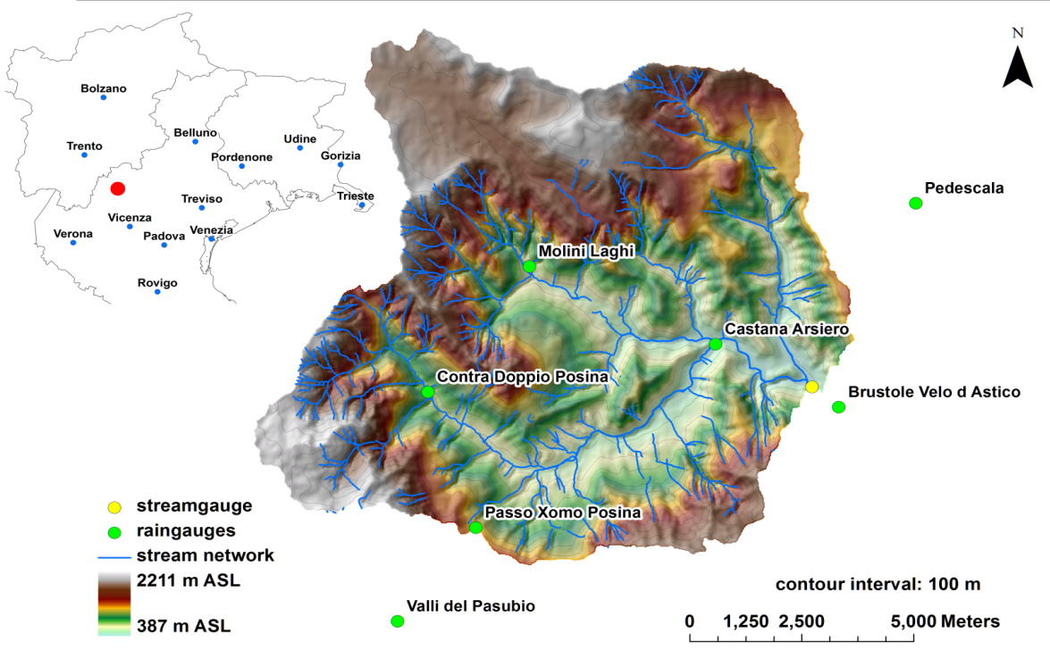
Figure 1 The Posina river basin: the figures illustrates the topography of the basin, the main river network, the location of the raingauges and of the streamgauge, and its position in north-eastern Italy.
Tables should be numbered consecutively (in Arabic numbers). Table headings should be placed above tables: 10 pt Times New Roman, 12 pt space above table heading to text, 6pt space below to table. Detailed explanations or entries should be typed directly beneath the table. Position tables at the top or bottom of a page and place them as close as possible to where they are mentioned in the main text.

Table 1: Main morphological and soil properties characteristics of the Posina catchment

Catchment
Area (km²)
Outlet altitude (m a.s.l.)
Max altitude (m a.s.l.)

  - Computation of the mean areal rainfall

Here you describe the procedure for estimating the mean areal rainfall over the Posina basin by using the Thiessen procedure (as a supplement, you may also use any other procedure you think appropriate). Report a description of the procedure and of the obtained results.
Use style ‘Equation’ for displayed equations. They should be centred, 6pt space above and below to the text. Equation numbers should be flush right. Please use Equation Editor to create displayed equations. Below is an example:
. (1)

  - Computation of the observed flood hydrograph and of the base flow

Here you describe the procedure for obtaining the observed flood hydrograph based on the measured hourly stage elevation at Stancari and the stage-discharge rating curve.
Moreover, you need to obtaine the ‘direct’ flood hydrograph from the observed flood hydrograph. This is required because the rainfall-runoff model based on combining the CN-SCS method and the unit hydrograph only computes surface flow (no subsurface flow computation is included in the model). Therefore, it is necessary to isolate the base flow contribution (originated by subsurface and groundwater) into the observed hydrograph. You will use a graphical methods to plot the baseflow component by
- identifying the starting point of the direct flood hydrograph (the corresponding discharge value is used to determine the baseflow) (this time and value may be taken equal to 31 October, 06:00 and 3.3 m³/s, respectively);
- identifying the point where the baseflow intersects the falling limb, where the direct hydrograph ends (this time and value may be taken 2 November, 23:00 and 56 m³/s, respectively);
- the separation between baseflow and direct flow is carried out by continuing the baseflow (3.3 m³/s) under the flood peak and then connecting with a straight line to the recession curve as defined above.
After this, the baseflow component is subtracted from the observed hydrograph, thus obtaining the direct hydrograph.

  - Computation of the Curve Number value and runoff ratio

This is obtained by using the inverse formulation of the Curve Number.
For a given pair of runoff (Q) and rainfall (P) event-cumulated values, the value of the potential retention S is obtained as follows:

(2)

where Ia is the multiplicative parameter of the initial abstraction (usually taken at 0.2).
Then the value of curve number (CN) may be obtained based on the value of S.
The value of CN will then be used to simulate the hourly runoff generation.
You will try several values of Ia in order to get a correct interpretation of the flood hydrograph.

  - Computation of the event runoff ratio

After identification of the best parameter set for the CN model, you compute the event runoff ratio as the ratio between the modeled direct runoff depth and the areal-averaged rainfall depth.

  - Development of scenarios with prescribed land use/land cover changes (volunteer)
Develop here analysis of the hydrological impact of two scenarios of land use/land cover changes. These may result to be 10% more and 10% less than the CN used for the simulation of the 2010 flood.

  - Conclusions

Here you report the conclusions from the study, reporting what you have learned from the exercise and discussing the following point:
- Major features of the rainfall runoff event: rainfall duration, peak discharge, rainfall and runoff depth, runoff ratio;
- Major features of the simulation: final values for CN and IA values and how realistic these are; importance of the base flow component with respect to the direct flow.
- Impact of land use change.

  - References

Examples
Journal papers
Ponce, V.M., Hawkins, R.H., 1996: Runoff curve number: Has it reached maturity? Journal of Hydrologic Engineering, 1 (1), 11-18.

Conference papers
Wasserman, C., 1999: Preserving the archival legacy of book publishers. In Proceedings of the 28th annual conference of the Special Library Association, edited by John Grossman. New York: Citadel Press.

Books
Wasserman, C., 1985: Microfilm and preservation: The medium everyone loves to hate. Englewood, Colo., Libraries Unlimited.

Part 2: Sensitivity analysis of the Penman-Monteith model for transpiration and for evaporation

ntroduction

Here you provide a description of the objectives and structure of the work.
The overall objective of the work is to perform a sensitivity analysis of the Penman-Monteith equation based on the following scenario:
Pine forest at Thetford, England, in August.
The following typical conditions apply for the Scenario:

Vegetation height=1650 cm;
Leaf Area Index=2.8
Maximum conductance of the leaf (C*leaf)=0.2 cm s⁻¹
Air pressure=1013 mb
Incident radiation= 0.00694 cal cm⁻² s⁻¹
Albedo=0.18
Ouward radiation= 0.00138 cal cm⁻² s⁻¹
Air temperature=19.2°
Relative humidity=0.54
Wind velocity=300 cm s⁻¹
Soil moisture deficit= 0 cm (saturated conditions) and 7 cm (dry conditions)

The specific objectives of the work are listed as follows:
Each student group will consider different groups of variables for the sensitivity analysis:
Group 1: Analysis of the effect of the atmospheric variables (air temperature, radiation, wind, relative humidity)
Group 2: Analysis of the effect of vegetation height, of the LAI and of the variable identified as ‘fs’
Group 3: Analysis of the effect of soil moisture and C*leaf

In each following section, report a description of the procedure and comment the obtained results.
The computation will be carried out by using Excel files.

  - Presentation of the Penman-Monteith model for transpiration and for evaporation
Here you describe the model, the relevant variables with their units.

  - Presentation of the methodology for the sensitivity analysis
Here you describe the variable considered in the sensitivity analyses and the range of values considered.

  - Presentation of the results and conclusions
Here you describe the results and report what you have learned from the exercise.

  - References

Examples
Journal papers
Gong, L., Xu, C.-y., Chen, D., Halldin, S., Chen, Y.D., 2006: Sensitivity of the Penman-Monteith reference evapotranspiration to key climatic variables in the Changjiang (Yangtze River) basin. Journal of Hydrology, 329 (3-4), 620-629.

Conference papers
Wasserman, C., 1999: Preserving the archival legacy of book publishers. In Proceedings of the 28th annual conference of the Special Library Association, edited by John Grossman. New York: Citadel Press.

Books
Wasserman, C., 1985: Microfilm and preservation: The medium everyone loves to hate. Englewood, Colo., Libraries Unlimited.

